*DIP REPORT*

2018701015

*Question 1: Linear Spatial Filter*

*1st Filter:*

*Initial Image Transformed Image*

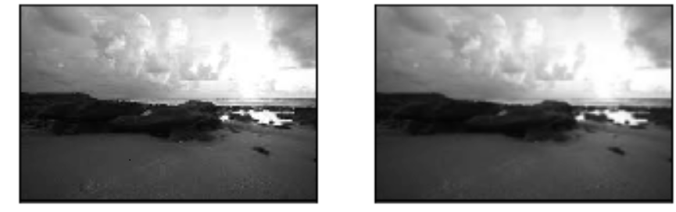

*2nd Image:*

*Initial Image Transformed Image*

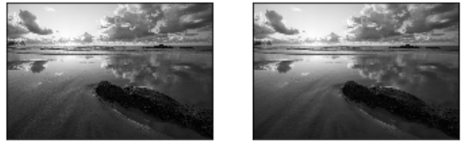

*2nd Filter:* 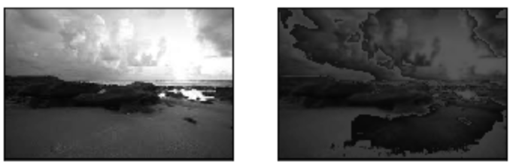

*Initial Image Transformed Image*

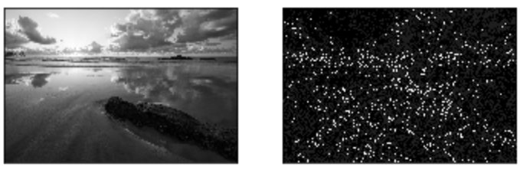

*3rd Filter: 2nd Image*

*Initial Image Transformed Image*

*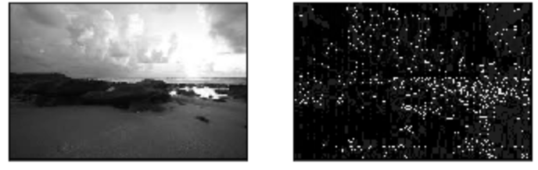*

*Modified Filter 1:*

*Initial Image Transformed Image*

*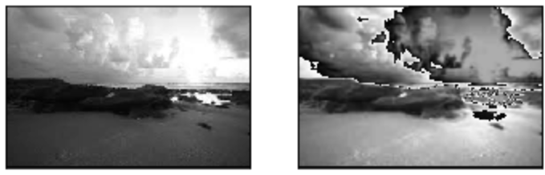*

*Modified Filter 1: Image 2*

*Initial Image Transformed Image*

*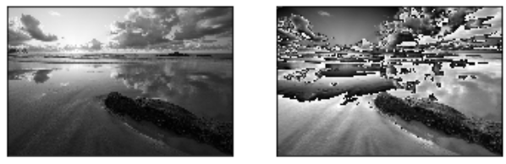*

*2nd Modified Filter: 1st Image*

*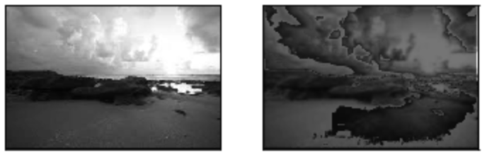*

*2nd Modified Filter: 2nd Image*

*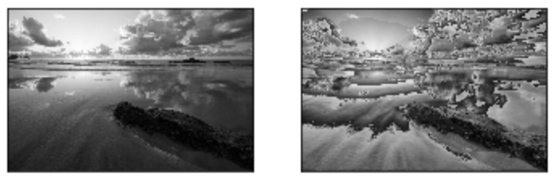*

*3rd Modified Filter :1st Image 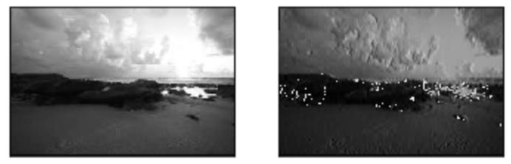*

*3rd Modified Filter 2nd Image*

*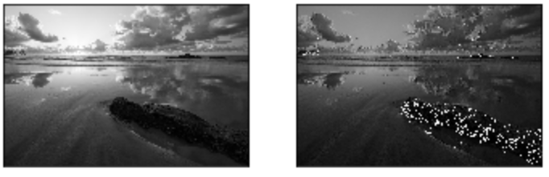*

*Q1: Part(b) - Modified Filter increases the amplitudes of the 2D signal which causes washing of the image and the filters which sum to zero causes the image to turn darker.*

*Q1: Part© - The filters which sum to 1 keep the amplitude constant whereas the filters which sum to 0 are used as edge detectors.*

Answer-2 check image Question-2.jpg

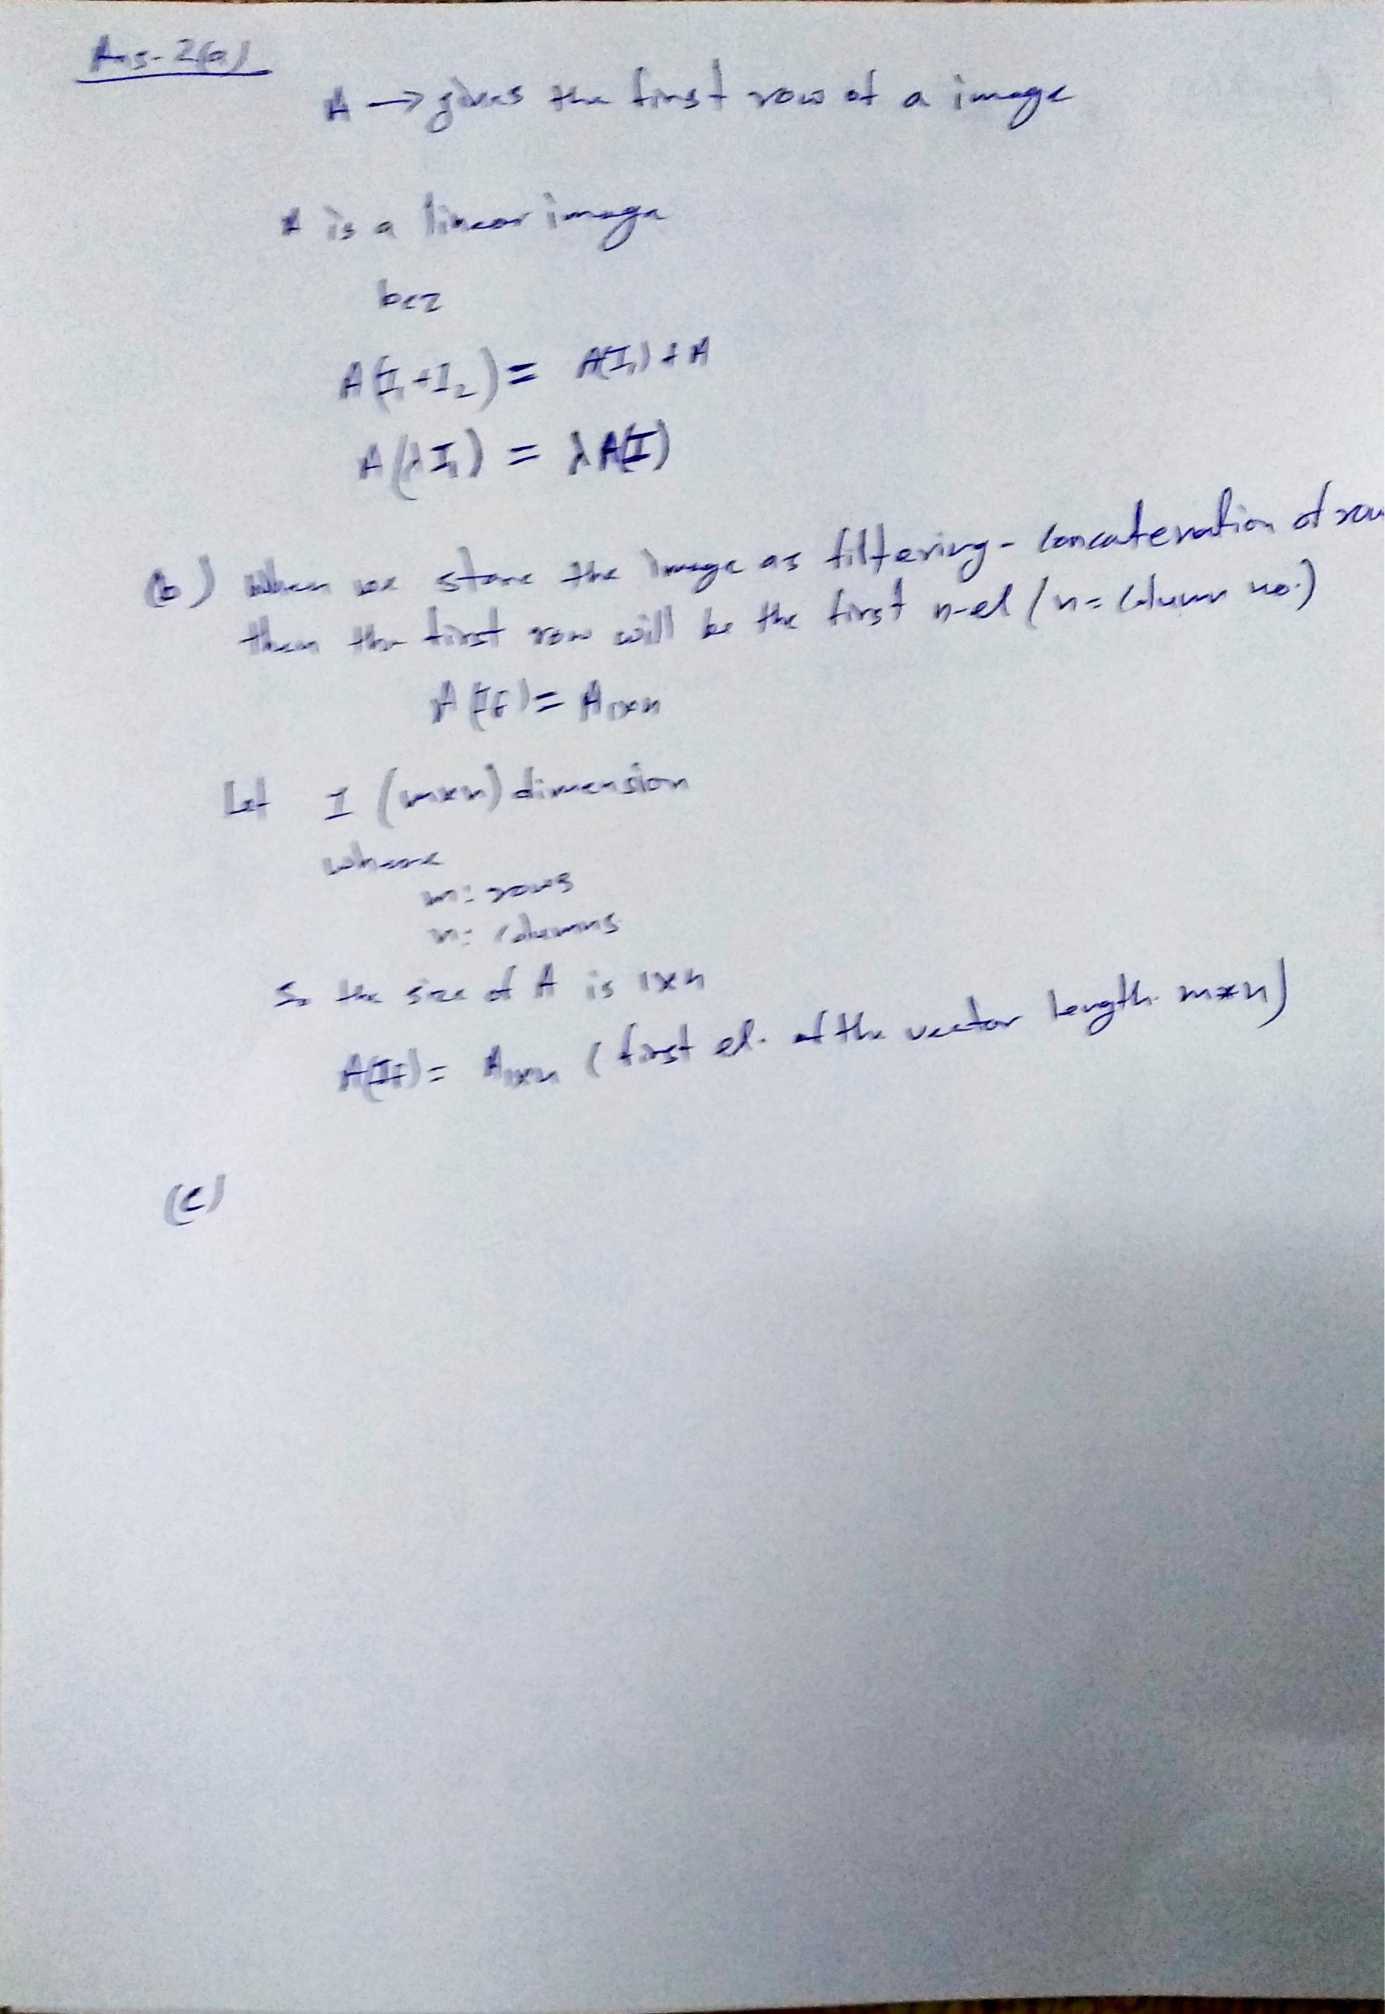

Answer-3 check image Question-3.jpg

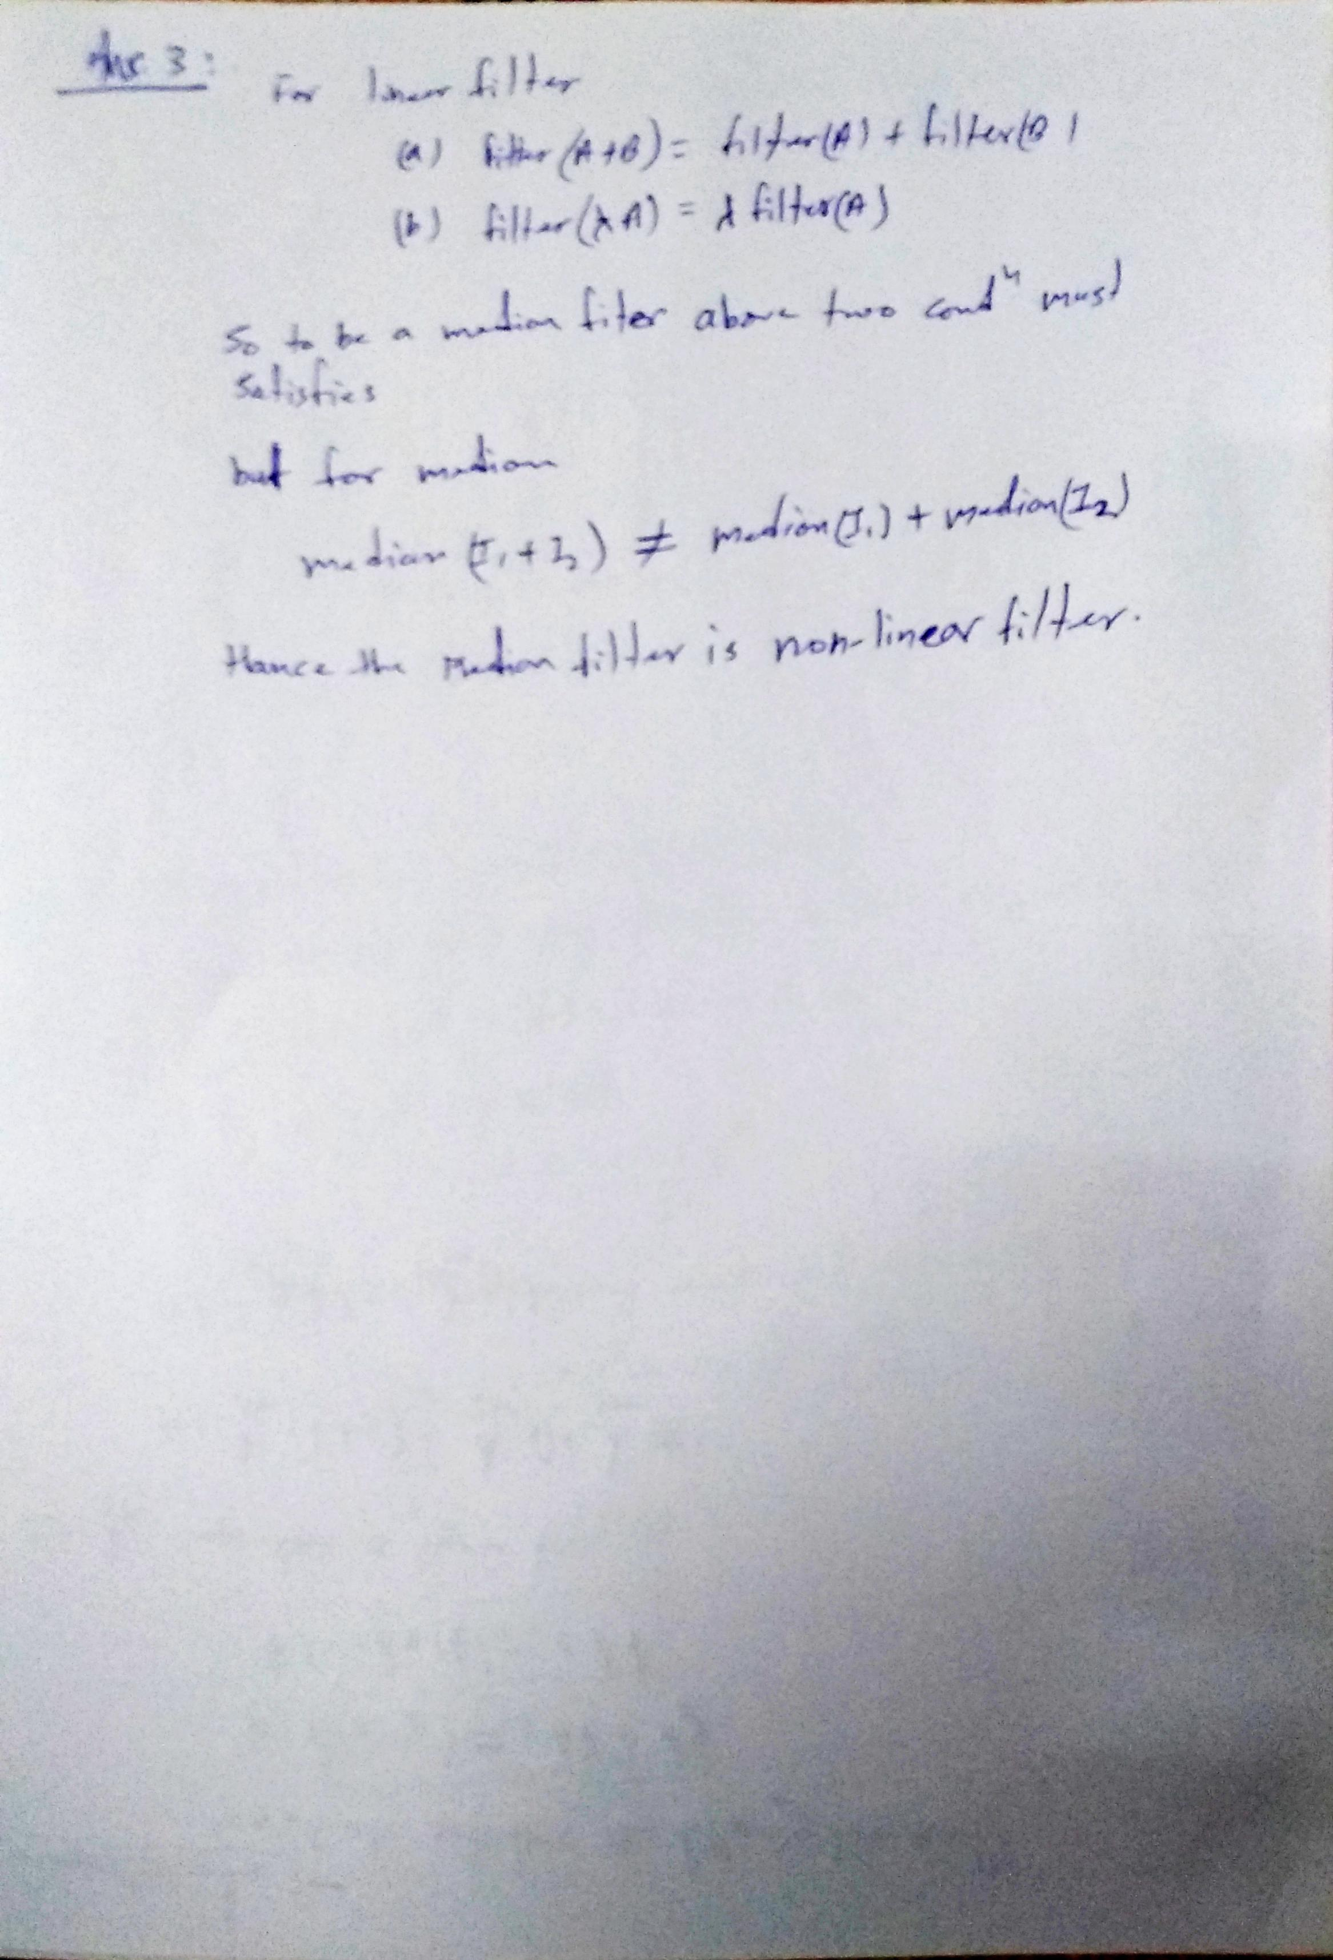

Answer-4 check Jupyter Notebook Question-2.ipynb

Answer-5 and 6 check image Question-5.jpg

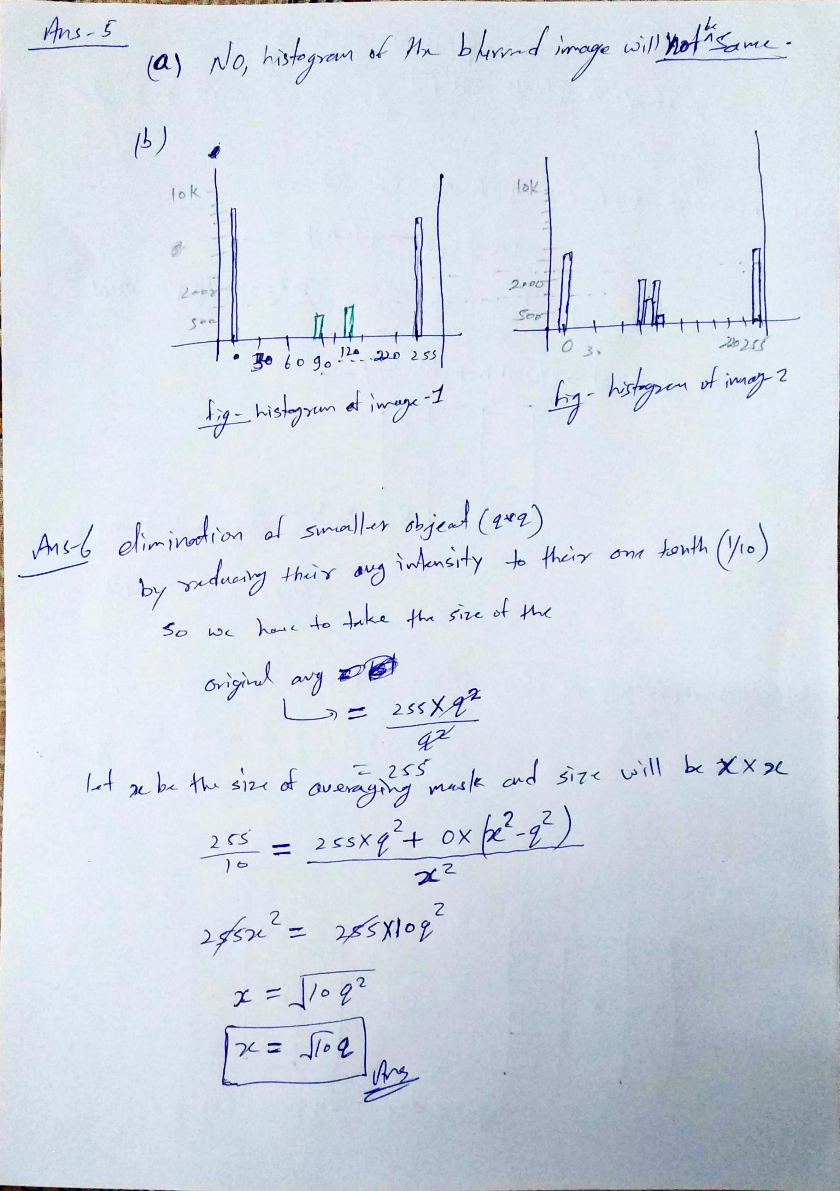

For answer-7 and 8 check image Question-6.jpg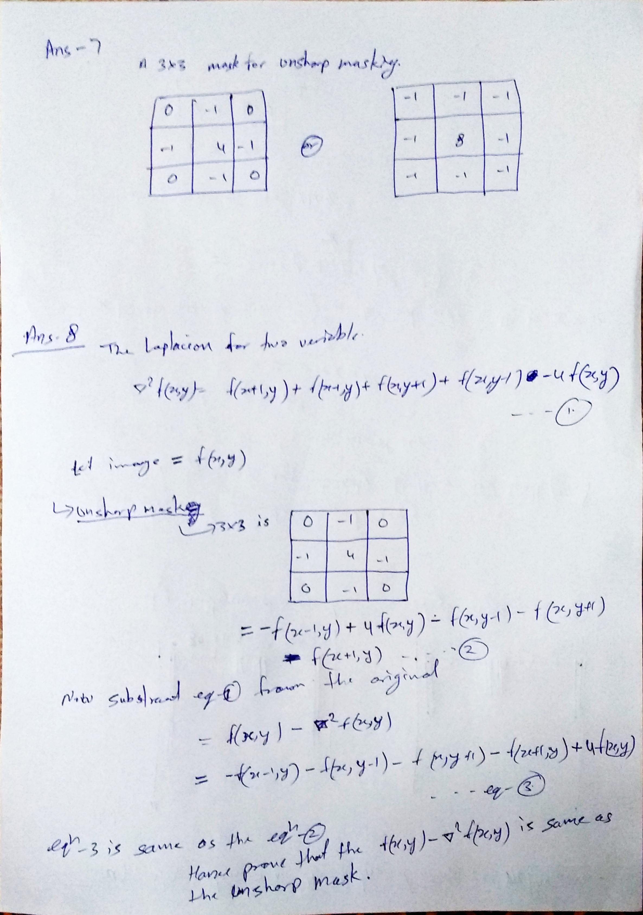

For answer-9 part-a check image Question-9-1.ipynb

For answer-10 part-a check image Question-10-1.ipynb